

INTERNATIONAL BUSINESS – BBB4M1
IDEATION and STORY BOARD REPORT: TASK DT4 V2.4

Preamble: In this exercise, we want to capture your input into 3 key areas of your Passion Project and international business. These areas, will move you closer to having a coherent plan for your new international business. Here, our focus will be on i. where you will have an international presence (what the citizens of that area look like - economically and skill sets), ii. the corporate cultural values you would like to have for your company, and iii what the Value Proposition is of your product of service. A map is also required. There are more structures for you to take advantage of to improve your opportunities for success as well e.g. workshops, pre-made tables and process guides.

OVERVIEW - SUMMATIVE STRUCTURE: The summative task is intended to give you the best opportunity to demonstrate your learning throughout the course. To do that, we have constructed it as follows:

- It is in report format. That means that you are using the same format that we practiced in DT1, DT2, and DT3 i.e. title page, paragraphs, indentation, bolding, sub headers, etc. Consider some of the practices used there to guide your submission;
- You will create a Value Proposition, investigate the people in your international location and consider the specific city and country of your international location, as well as explore the corporate cultural values you require for your product or company;
- Follow directions. If it says use a table, use the table provided in the Appendices of this Task.
- There are completion check-ins along the way and workshops for specific areas (office hours).

DT4 TASK: You still require a solid HMW or Problem Statement and may want or have to tweak your HMW. In addition, you will need to consider different location related possibilities. You will need to get feedback for some parts of this report from your Virtual Groups.
1

CONTENT: Continuing in your mindset as a principal officer of a new company that has international aspirations, you are now in the position to start putting a business plan together. This is a 3rd step. Content will come from your previous formative practice with the Value Proposition, Gapminder, Culture 500, and Maps. Please complete the following:

The report will have these content requirements:

- Title Page - You will need a Title Page (TP). The TP will need an image of your World Map (See Content point # 4) complete with locations of your VG Group members and place it in the centre of the page. You will also need a descriptive title at the top of the page. In the bottom third of the page, closer to the bottom, put your static data;
Knowledge 4 and 4 Communication Marks;

- Report Body: HMW Statement - On page 1 of the report, insert your Problem or HMW Statement into a textbox at the top of the page. In the same text box but on a separate line, put your Value Proposition;
Knowledge 4 and 2 Communication Marks;

- Report Body: HMW – In your first section, tell us whether you changed your HMW based on anything that may have happened in either the creation or discussion of your Value Proposition, consultation, or just a general thought process. Name who you consulted with if you did. Be descriptive about your reason for change or no change. Change should consider the POV as well. Make sure you have a good sub header. Call it, Section 1 – HMW and POV Change Rationale;
Knowledge 2 and Thinking Marks 2 marks each – 4 marks total;

- Report Appendix: Appendix I - Value Proposition Table. Complete the Table in Appendix I – Value Proposition Table. The table is found in appendices from this Task below. Complete the Table by choosing a Customer Segment. Choose 3 Jobs (To Be Done) for the chosen Customer Segment. Choose 2 Pains and 2 Gains for the MOST IMPORTANT Customer Job. Insert behind Appendix I;
Knowledge 8 and Application 1 mark each – 8 marks total;

- Report Body: Value Proposition – In Section 2, reflect on what happened in your Value Proposition Table. Call it, Section 2 – Value Proposition Rationale. Describe the process that occurred as you considered the customer segment you wanted to focus on. How did this affect your creation or lead to the development of a value statement?
Knowledge 2 and Application 4 marks;

Once you have the 3 Jobs (to be done) and chosen what you think the most important one is, consider what the most important Pains and Gains for that customer segment’s Job (to be done). You will have 2 paragraphs: one for the process of what you thought of in selecting the jobs and why you focused on them and one for the Pains and Gains and why you focused on them. Make sure you have good sub headers. There should be more than one sub header;
Knowledge 2 and Thinking 3 mark each – 6 marks total;

- Report Appendix: If you haven’t already, create 4 Dividers: A Divider labeled Appendices, a Divider labeled Appendix I – Value Proposition Table, another labeled Appendix II – World Locations, and finally, create another Divider called Appendix III – World Location: Detail;
Knowledge 4 and Communication 4 marks;

- Report Jamboard: Map – Save World Map template found in Appendix II below as image in your personal file or Google Drive. Open Jamboard. Import image into your Jamboard. Label Jamboard: Your Name (First, Last all caps) International Presence. Share Jamboard with instructor.
Knowledge 4 and Communication 4 marks;

Using the shape function on Jamboard, insert a coloured circle on the approximate location of either Toronto or another Canadian location which will be your head office. Place circles on 3 other locations where your Virtual Group members have planned to have some international presence (sales office, manufacturing, regional representative, etc. Use the line function and draw a straight line to each of the foreign offices including your own.
Communication 6 marks;

- Report Appendix: Appendix II – World Locations Map. Download and save a PDF or image copy of your Jamboard. Insert the Jamboard image or PDF with the map of the foreign presence of you and your Virtual group behind the divider Appendix II – World Locations of your report.
Application 4 marks;

- Report Appendix: Appendix III – World Locations: Detail. Using the Table from Appendix III below, complete the descriptions of the Virtual Group Members and their international locations. Insert the table behind divider Appendix III – World Locations: Details of your report;
Knowledge 4 and Application 1 mark each – 4 marks max;

- Report Body: Global Location Analysis. Create a sub header. Call it, Section 3 – Global Location Analysis. Using the table and map as guides, describe what you see in terms of patterns and what the reason is for pattern. This could include patterns of countries, cities within the countries (both in Canada and offshore). You will need at least 1 paragraph of 3 sentences;
Knowledge 2 and Thinking 6 marks;

- Report Appendix: If you haven’t already, create 3 more Dividers: A Divider labeled Appendix IV – Gapminder Table, another labeled Appendix V – Culture 500 Values, and finally, create another Divider called Appendix VI – Work Cited;
Knowledge 3 and Communication 3 marks

- Report Appendix: Appendix IV –Gapminder. Complete the Table from Appendix lV below. Insert the completed table behind a Divider you create called Appendix IV – Gapminder of your report. Find your country in Gapminder.org. If your country is not there, find a country close by or an alternative. Next, find a family in a city closest to where you want an international presence. What type of presence do you want to have there? A representative? A sales office? A local representative?
Or someone from your head office there to oversee production? Whatever your choice, describe what the role will be in one or two words. Include monthly income of family in table.

Of the many items that Gapminder has photos of, choose 2 and place them in the table. Insert a copy of the photo that they have taken of the item.
Knowledge 8 and Communication 8 marks

- Report Body: Gapminder: Create a sub header. Call it, Section 4 – Gapminder. Using the table and the content as guides, describe AND reflect on what you see in terms of the items and the amount of money the family earns. What does that mean for your company? If you sent someone from the head office to run an operation there, what could they expect based on the images and items you chose? Or if you have to hire a local for something, what could you expect to have to pay in terms of monthly family incomes? Consider your scenario and analyze the effect of living conditions on it. You should have 2 paragraphs of a minimum 3 sentences each.
Knowledge 2 and Thinking 8 marks

- Report Appendix: Appendix V – Culture 500. Complete the Table from Appendix V below. Using the website, Culture 500 (https://sloanreview.mit.edu/culture500/), choose an industry, a company, and 2 corporate cultural values that most represent what you would like your company and its employees to have. Make sure you have copied your Value in from Culture 500;
Knowledge 6 and Communication 6 marks

- Report Body: Culture 500. Create a sub header. Call it, Section 5 – Culture 500. When you have completed the table, create 4 sub – headers for the main topics and Values chosen (Industry, Company, Corporate Value #1 and Corporate Value #2), reflect on each one of the topics. Why does the industry attract you in relation to the Passion Project? What effect do these corporate values will have on your Passion Project International company? You need to consider why chosen corporate cultural values are important to you and your potential employees. Can you say that the employer has walked the talk? Why or why not?
Knowledge 6 and 12 Thinking Marks;

- Report Appendix: Work Cited – Appendix VI. Here, we expect that any research you have done to inform your work is captured here. A bare minimum would be the images selected, corporate values, and any other site used to get your information. Use a citation app and put it in the Work Cited as well.
12 Communication Marks;
3

FORMAT: As business people, we have to be able to get the understanding of something quickly. The content comes from your previous formative practice with these each of the websites and templates used here. Please do the following:

The report will have these format requirements:

- Title Page - Place the image in the centre of the page. Do not let the image cover more than 20% of the Title Page. The Title is in upper case for all important words and bolded. at the top of the page. In the bottom third of the page, put your static data (name, exact course code e.g. BBB4M1-12, instructor, and due date).
6 Communication Marks;

- Report Body: HMW Statement and Value Proposition - On page 1 of the report, put a text box with black bolded border and insert your Problem/HMW Statement and Value Proposition. The Value Proposition must be separated from the Problem/HMW statement and on a different line;
4 Communication Marks;

- Report Body: All sections of the body of your report should have subtitles that give the reader the understanding of the content and are concise. You should use subtitles that have more than 1 part and label it accordingly. E.g. under Culture 500 you may have a. Industry b. Company c. Corporate Value #1, etc.
8 Communication Marks;

- Report Appendices: You will have 6 pages called dividers. There is one new one. It is simply called Appendices. They simply divide the information in the Appendices. One divider will be called Appendix I (that is Roman Numeral I; not a lower case “L” and not a 1). The sheet is blank with the exception of the title. E.g. “Appendix I which bolded and centred on the page with the appropriate label e.g. Appendix I – Value Proposition. The Table you complete will come behind it. The second divider will say Appendix II – World Locations and so on.

- Work Cited Appendix Vl. We are using MLA style for Citations. Use proper MLA format and use a Citation App such as BibMe or Citation Machine. Put it in as part of your work cited. There are many. Pick one that is good for you;
5 Communication Marks;

- Final Submission – Save your document in a PDF when you are done and have an appropriate file name that includes your name and the task name. You must share your Jamboard independent of the report. PDF’s of report will preserve the formatting you want me to see. This is simply choosing the PDF format when saving the document. See the Style Guide’s new section on PDF’s.
12 Communication Marks;
4

Due Date: Wednesday December 9th, by 20:00 PM. Late Penalties will be in effect. The final submission is to be done by sharing the final PDF version with me. Do not, do not, submit to Google Class. Marks will be deducted for this. There will be compulsory check – in dates for completion.

APPENDICES

APPENDIX I -
VALUE PROPOSITION TABLE

Value Proposition Table

CUSTOMER SEGMENT | JOBS | PAINS (MOST IMPORTANT JOB) | GAINS (MOST IMPORTANT JOB)
PUT YOUR CUSTOMER SEGMENT HERE | LEAVE BLANK | LEAVE BLANK | LEAVE BLANK
 | 1. | 1. | 1.
 | 2. | 2. | 2.
 | 3.

Appendix II –
World Locations

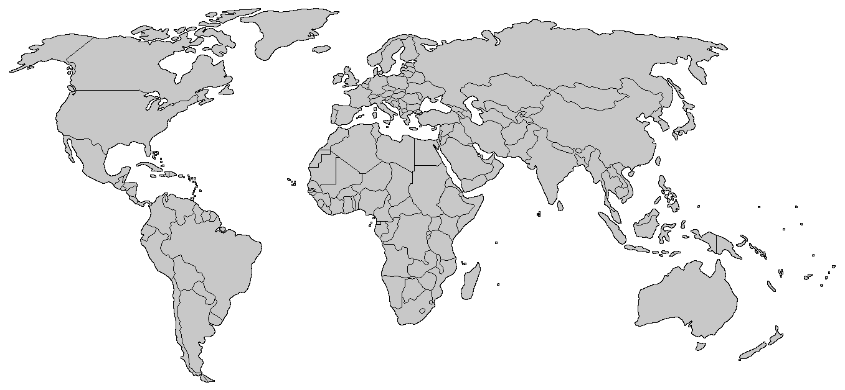

Appendix: Appendix III – World Locations: Detail

World Locations: Detail

VIRTUAL GROUP NUMBER AND MEMBERS | COUNTRY | CITY | COLOUR OF DOT
PUT YOUR VG MEMBER NAME HERE
PUT YOUR VG MEMBER NAME HERE
PUT YOUR VG MEMBER NAME HERE
PUT YOUR VG MEMBER NAME HERE
PUT YOUR VG MEMBER NAME HERE

Appendix IV – Gapminder

Gapminder:

COUNTRY | ITEM #1 | ITEM #2 | MONTHLY INCOME
PUT COUNTRY NAME HERE | PUT NAME OF ITEM HERE | PUT NAME OF ITEM HERE | $$$$
PUT CITY NAME HERE | INSERT PHOTO HERE. EXPAND AS NEEDED. | INSERT PHOTO HERE. EXPAND AS NEEDED.
PUT ROLE OF INDIVIDUAL HERE

Appendix V – Culture 500

Culture 500 Table

INDUSTRY | COMPANY | CORPORATE CULTURAL VALUE
PUT INDUSTRY NAME HERE | PUT COMPANY NAME HERE | LEAVE BLANK
 | PUT VALUE #1 NAME HERE. E.G. AGILITY | PUT DEFINITION OF CORPORATE VALUE HERE. THIS MUST COME FROM THE CULTURE 500 SITE
 | PUT VALUE #2 NAME HERE. E.G. AGILITY | PUT DEFINITION OF CORPORATE VALUE HERE. THIS MUST COME FROM THE CULTURE 500 SITE

